EXERCISE 1:

1.React Js-HOL

App.js :

import React from 'react';

function App() {

return (

<div>

<h1 ><center>Welcome to the first session of React</center></h1>

</div>

);

}

export default App;

**OUTPUT:**

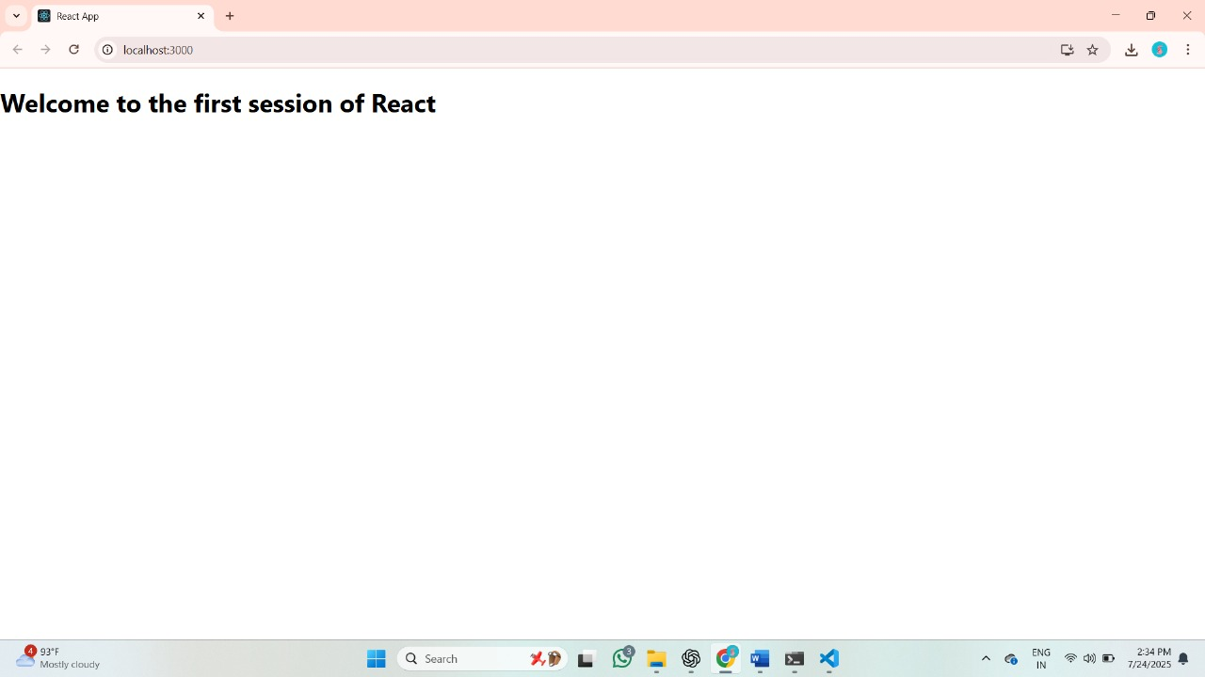

EXERCISE 2:

Components/Home.js :

import React, { Component } from 'react';

class Home extends Component {

render() {

return (

<div>

<h2>Welcome to the Home page of Student Management Portal</h2>

</div>

);

}

}

export default Home;

Components/About.js :

import React, { Component } from 'react';

class About extends Component {

render() {

return (

<div>

<h2>Welcome to the About page of the Student Management Portal</h2>

</div>

);

}

}

export default About;

Components/Contact.js :

import React, { Component } from 'react';

class Contact extends Component {

render() {

return (

<div>

<h2>Welcome to the Contact page of the Student Management Portal</h2>

</div>

);

}

}

App.js : import React from 'react';

import './App.css';

import Home from './Components/Home';

import About from './Components/About';

import Contact from './Components/Contact';

function App() {

return (

<div className="App">

<Home />

<About />

<Contact />

</div>

);

}

export default App;

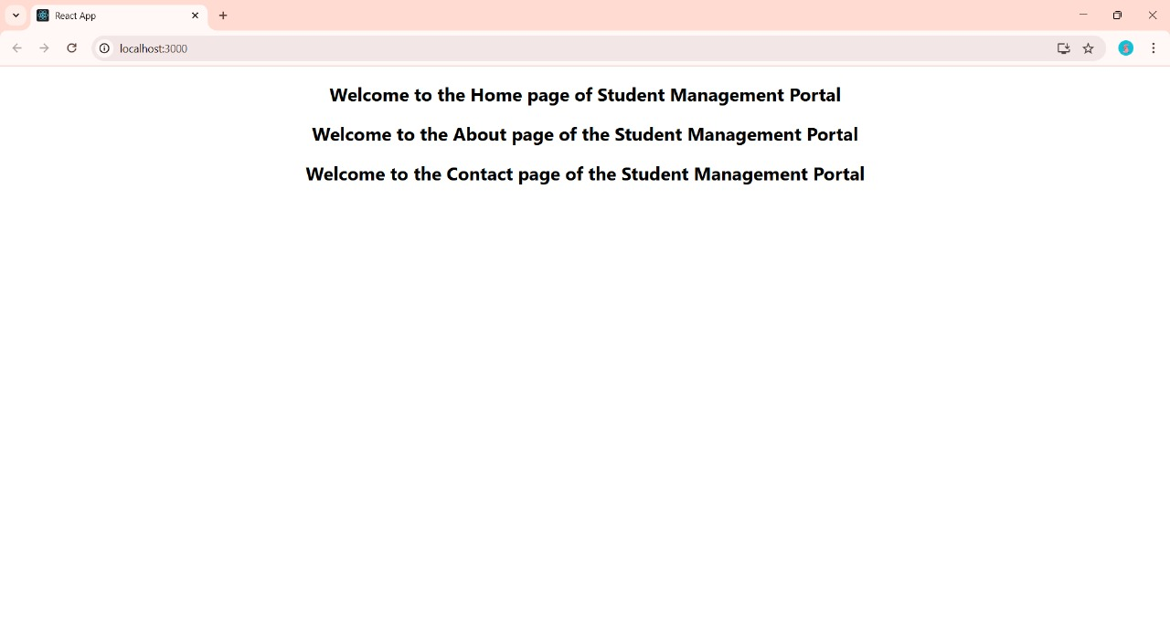 **OUTPUT:**

EXERCISE 3:

Components/ScoreCalculator.js :

import React from 'react';

import '../Stylesheets/mystyle.css';

function CalculateScore(props) {

const { name, school, total, goal } = props;

const average = total / goal;

return (

<div className="score-container">

<h2>Student Score Details</h2>

<p><strong>Name:</strong> {name}</p>

<p><strong>School:</strong> {school}</p>

<p><strong>Total Marks:</strong> {total}</p>

<p><strong>Subjects:</strong> {goal}</p>

<p><strong>Average Score:</strong> {average.toFixed(2)}</p>

</div>

);

}

export default CalculateScore;

mystyle.css :

.score-container {

background-color: #f0f8ff;

border: 2px solid #064b4b;

padding: 20px;

margin: 20px auto;

width: 50%;

border-radius: 10px;

font-family: Arial, sans-serif;

box-shadow: 0 4px 8px rgba(0, 0, 0, 0.2);

}

.score-container h2 {

color: #085c5c;

text-align: center;

}

.score-container p {

font-size: 18px;

line-height: 1.5;

}

import React from 'react';

import './App.css';

import CalculateScore from './Components/CalculateScore';

function App() {

return (

<div className="App">

<CalculateScore

name="Kavimanjari L"

school="Amalorpavam HR Sec school"

total={550}

goal={6}

/>

</div>

);

}

export default App;

**OUTPUT:**

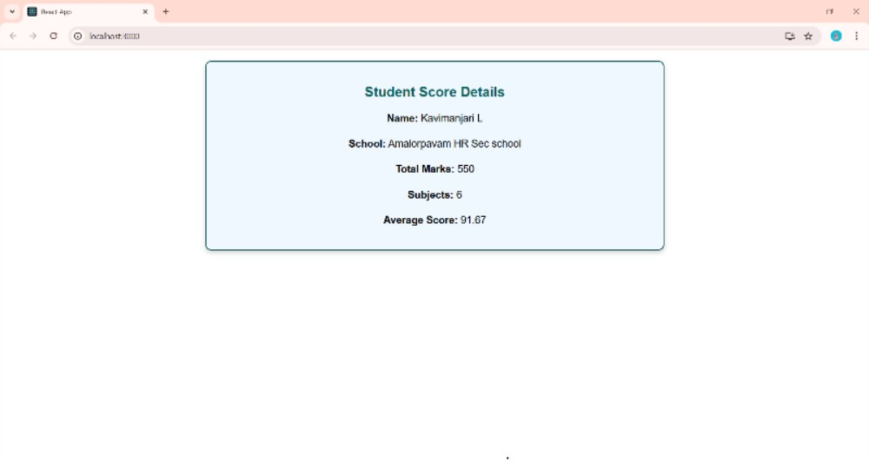

EXERCISE 4:

Post.js :

class Post {

constructor(id, title, body) {

this.id = id;

this.title = title;

this.body = body;

}

}

export default Post;

Posts.js :

import React, { Component } from 'react';

class Posts extends Component {

constructor(props) {

super(props);

this.state = {

posts: [],

hasError: false,

};

}

loadPosts() {

const englishPosts = [

{

id: 1,

title: 'The Power of Positive Thinking',

body: 'Positive thinking helps you build a better mindset, reduce stress, and improve overall well-being. It does not mean ignoring life’s challenges but facing them with a constructive attitude.',

},

{

id: 2,

title: 'Time Management for Students',

body: 'Effective time management is essential for academic success. Prioritize your tasks, avoid procrastination, and use tools like calendars and to-do lists to stay organized.',

},

{

id: 3,

title: 'Benefits of Daily Exercise',

body: 'Daily physical activity boosts your energy, improves mood, and strengthens your heart. Even a 30-minute walk can make a big difference in your health.',

},

{

id: 4,

title: 'How to Stay Focused While Studying',

body: 'Eliminate distractions, take regular breaks, and set small achievable goals. Create a dedicated study space and reward yourself after completing tasks.',

},

{

id: 5,

title: 'Why Reading Books Improves Your Brain',

body: 'Reading enhances memory, vocabulary, and imagination. It stimulates your brain, improves empathy, and helps you become a better communicator.',

},

];

setTimeout(() => {

this.setState({ posts: englishPosts });

}, 3000);

}

componentDidMount() {

this.loadPosts();

}

componentDidCatch(error, info) {

alert("An error occurred while rendering posts.");

console.error("Caught error:", error, info);

this.setState({ hasError: true });

} render() {

const { posts, hasError } = this.state;

if (hasError) {

return <h2 style={{ color: 'red' }}>Something went wrong.</h2>;

}

return (

<div>

<h1>Blog Posts</h1>

{posts.length === 0 ? (

<p>Loading posts...</p>

) : (

posts.map((post) => (

<div key={post.id} style={{ marginBottom: '20px' }}>

<h3>{post.title}</h3>

<p>{post.body}</p>

</div>

))

)}

</div>

);

}

}

export default Posts;

App.js :

import React from 'react';

import './App.css';

import Posts from './Posts';

function App() {

return (

<div className="App">

<Posts />

</div>

);

}

export default App;

**OUTPUT:**

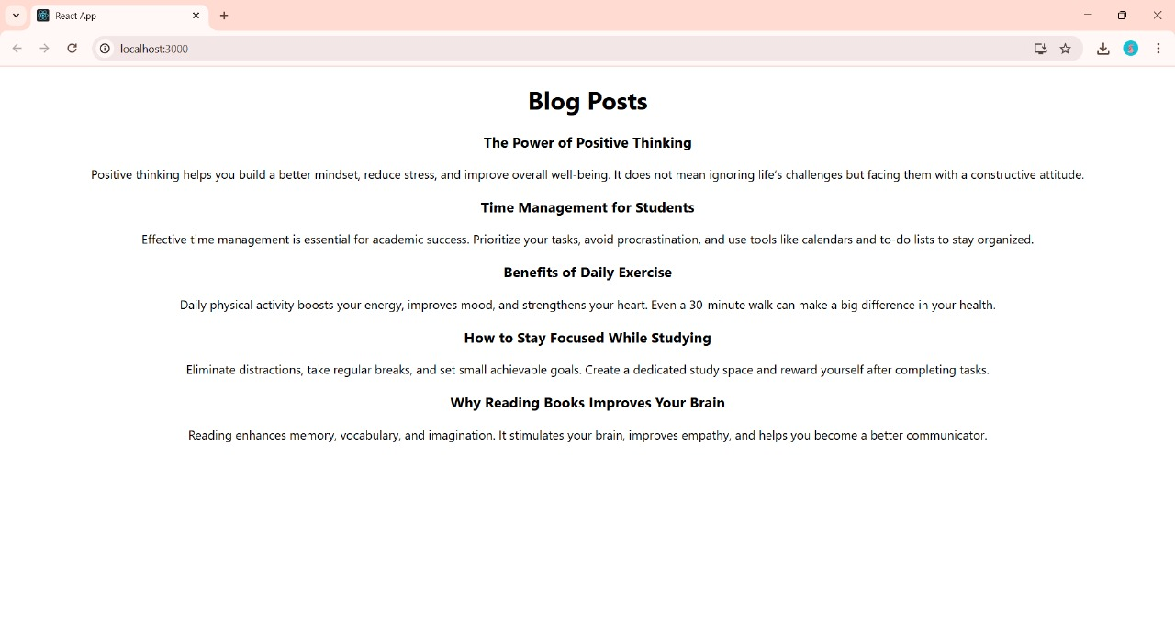

EXERCISE 5:

Cohort.js :

class Cohort {

constructor(cohortCode,

startDate,

technology,

trainerName,

coachName,

currentStatus) {

this.cohortCode = cohortCode;

this.coachName = coachName;

this.trainerName = trainerName;

this.technology = technology;

this.startDate = startDate;

this.currentStatus = currentStatus;

}

}

const CohortsData =[

new Cohort('INTADMDF10','22-Feb-2025', '.NET FSD', 'Jojo Jose','Aathma', 'Scheduled'),

new Cohort('ADM21JF014','10-APR-2024', 'Java FSD', 'Elisa Smith','Apoorv', 'Ongoing'),

new Cohort('CDBJF21025','24-APR-2025', 'Java FSD', 'John Doe','Aathma', 'Ongoing'),

new Cohort('INTADMJF12','22-Feb-2025', 'Java FSD', 'To Be Assigned','Ibrahim', 'Scheduled'),

new Cohort('CDE22JF011','24-Dec-2025', 'Java FSD', 'Emma Swan','Apoorv', 'Ongoing'),

new Cohort('INTADMDF09','22-Feb-2025', 'Dataware Housing', 'Babjee Rao','Aathma', 'Scheduled'),

new Cohort('ADM22DF001','10-Apr-2025', '.NET FSD', 'Marie Curie','Ibrahim', 'Ongoing'),

];

export {Cohort, CohortsData};

CohortDetails.js :

import React from 'react';

import styles from './CohortDetails.module.css';

function CohortDetails(props) {

const { cohortCode, technology, startDate, currentStatus, coachName, trainerName } = props.cohort;

const statusClass = currentStatus === 'ongoing' ? styles.ongoing : styles.completed;

return (

<div className={styles.box}>

<h3 className={statusClass}>

{cohortCode} - <span>{technology}</span>

</h3>

<dl>

<dt>Started On</dt>

<dd>{startDate}</dd>

<dt>Current Status</dt>

<dd>{currentStatus}</dd>

<dt>Coach</dt>

<dd>{coachName}</dd>

<dt>Trainer</dt>

<dd>{trainerName}</dd>

</dl>

</div>

);

}

export default CohortDetails;

CohortDetails.module.css :

.box {

width: 300px;

display: inline-block;

margin: 10px;

padding: 10px 20px;

border: 1px solid black;

border-radius: 10px;transition: 0.3s;

}

h1 {

text-align: center;

color: #333;

background-color: beige;

}

.box:hover {

background-color: #f0f0f0;

transform: scale(1.1);

}

dt {

font-weight: 500;

}

.ongoing {

color: green;

}

.completed {

color: blue;

}App.js :

import logo from './logo.svg';

import './App.css';

import { CohortsData} from './Cohort'

import CohortDetails from './CohortDetails';

function App() {

return (

<div>

<h1 >Cohorts Details</h1>

{CohortsData.map(cohort => <CohortDetails cohort={cohort}/>)}

</div>

);

}export default App;

**OUTPUT:**

